#################3.1

x1 <- c(0.48,40.53,2.19,0.55,0.74,0.66,0.93,0.37,0.22)

x2 <- c(12.57,73.68,11.13,20.03,20.29,0.78,4.64,0.43,1.08)

mu <- t(c(mean(x1),mean(x2)))

X <- matrix(c(x1,x2),ncol=2,byrow=FALSE)

S <- cov(X)

n <- length(x1)

xbar <- apply(X,2,mean)

C =c()

y <- function(z){

a <- nrow(z)

for (i in 1:a){

T0_sq <- (z[i,]-mu)%*%solve(S/n)%*%t(z[i,]-mu)

if (T0_sq > 8*2/7*qf(0.1,2,7,lower.tail=FALSE)){

z[i,] <- c(0,0)

}

}

return(z)

}

z <-(runif(50000)-1/2)*100

w <- (runif(50000)-1/2)*100

Z <- matrix(c(z,w),ncol=2,byrow = FALSE)

y(Z)

plot(y(Z),col="red")

%plot(Z[which(y(Z)!=0),],add=TRUE)

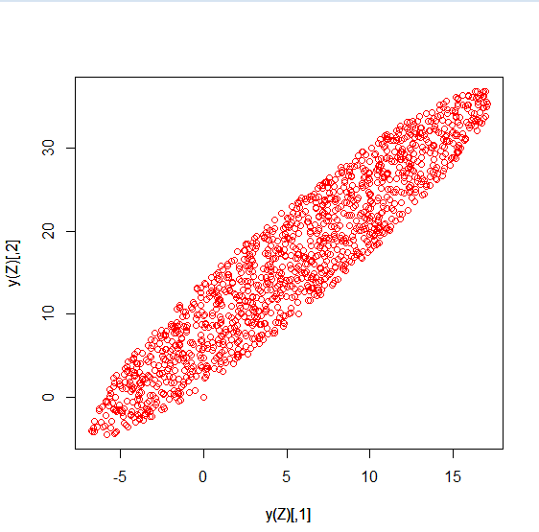

No, the center point coordinate is approximate be [5,15].

Point (0.3,10) will in the confidence region.

############################################4.1 Code

math1 <- c(50,60,65,55,55,50,60,50,60)

lan1 <- c(60,70,90,70,80,85,65,70,85)

math2 <- c(60,70,75,65,70,65,70,60,70)

lan2 <- c(40,50,60,50,60,65,45,50,65)

n <- length(math1)

t1 <- abs(mean(math1)-mean(lan1))/sqrt((1/n+1/n)*((n-1)*var(math1)/(n+n-2)+(n-1)*var(lan1)/(n+n-2)))

t1

tc <- qt(0.025,length(math1)-1,lower.tail = FALSE)

tc

t1 <- abs(mean(math2)-mean(lan2))/sqrt((1/n+1/n)*((n-1)*var(math2)/(n+n-2)+(n-1)*var(lan2)/(n+n-2)))

t1

tc <- qt(0.025,length(math1)-1,lower.tail = FALSE)

tc

# reject H0: mu1=mu2

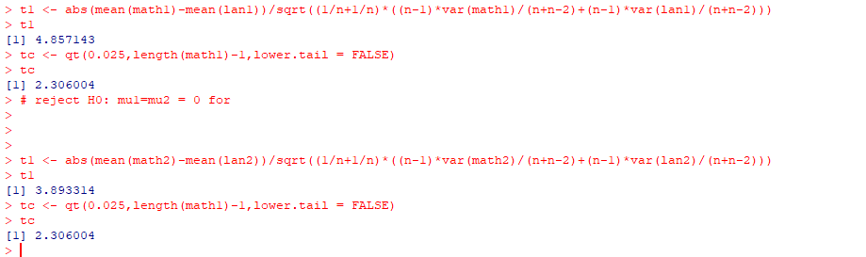

#########################3.2

#################################5

##################4.1

存疑~~~~~之后有空问问看

##################4.2

math1 <- c(50,60,65,55,55,50,60,50,60)

lan1 <- c(60,70,90,70,80,85,65,70,85)

math2 <- c(60,70,75,65,70,65,70,60,70)

lan2 <- c(40,50,60,50,60,65,45,50,65)

n <- length(math1)

mmean <- c(mean(math1),mean(math2))

lmean <- c(mean(lan1),mean(lan2))

cov1 <- as.matrix(cov(t(rbind(math1,math2))))

cov2 <- as.matrix(cov(t(rbind(lan1,lan2))))

Sp <- cov1/2+cov2/2

t1 <- t(mmean-lmean)%*%solve(sqrt((1/n+1/n)*Sp))%*%(mmean-lmean)

t1

tc <- qt(0.025,length(math1)-1,lower.tail = FALSE)

tc

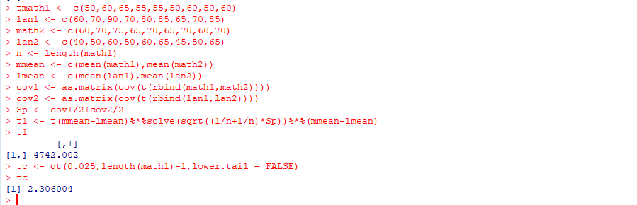

###############################################5. Code

T1 <- matrix(c(6,5,8,4,7,7,9,6,9,9),nrow=2,byrow=TRUE)

T2 <- matrix(c(3,1,2,3,6,3),nrow=2,byrow=TRUE)

T3 <- matrix(c(2,5,3,2,3,1,1,3),nrow=2,byrow=TRUE)

X <- t(cbind(T1,T2,T3))

xbar <- apply(X,2,mean)

xbar

x1bar <- apply(T1,1,mean)

x2bar <- apply(T2,1,mean)

x3bar <- apply(T3,1,mean)

n1 <- nrow(t(T1))

n2 <- nrow(t(T2))

n3 <- nrow(t(T3))

p <- ncol(t(T1))

n <- n1+n2+n3

S1 <- (n1-1)*cov(t(T1))

S2 <- (n2-1)*cov(t(T2))

S3 <- (n3-1)*cov(t(T3))

W <- S1+S2+S3

W

T <- (T1- xbar)%*%t(T1- xbar)+(T2- xbar)%*%t(T2- xbar)+(T3- xbar)%*%t(T3- xbar)

T

E <- (T1- x1bar)%*%t(T1- x1bar)+(T2- x2bar)%*%t(T2- x2bar)+(T3- x3bar)%*%t(T3- x3bar)

E

B <- T-E

B

g <- 4

####df: B = 4-1 = 3

####df: W = 5+3+4-3=9

####df: B+W = 3+9=12

#################################################5.2

###handwriting problem

#################################################5.3

LAMBDA <- det(E)/det(E+B)

LAMBDA

###Use p = 2, g >=2

STAT <- (12-g)/(g-1)*((1-sqrt(LAMBDA))/sqrt(LAMBDA))

STAT

qf(0.005,2*(g-1),2*(12-g),lower.tail=FALSE)

###Reject the Ho ,so there is significant difference between three treatments

